Here we updated two more products to check the functionality of the code that was product two and product four. Also made edits on the display of the work for smartness and readability.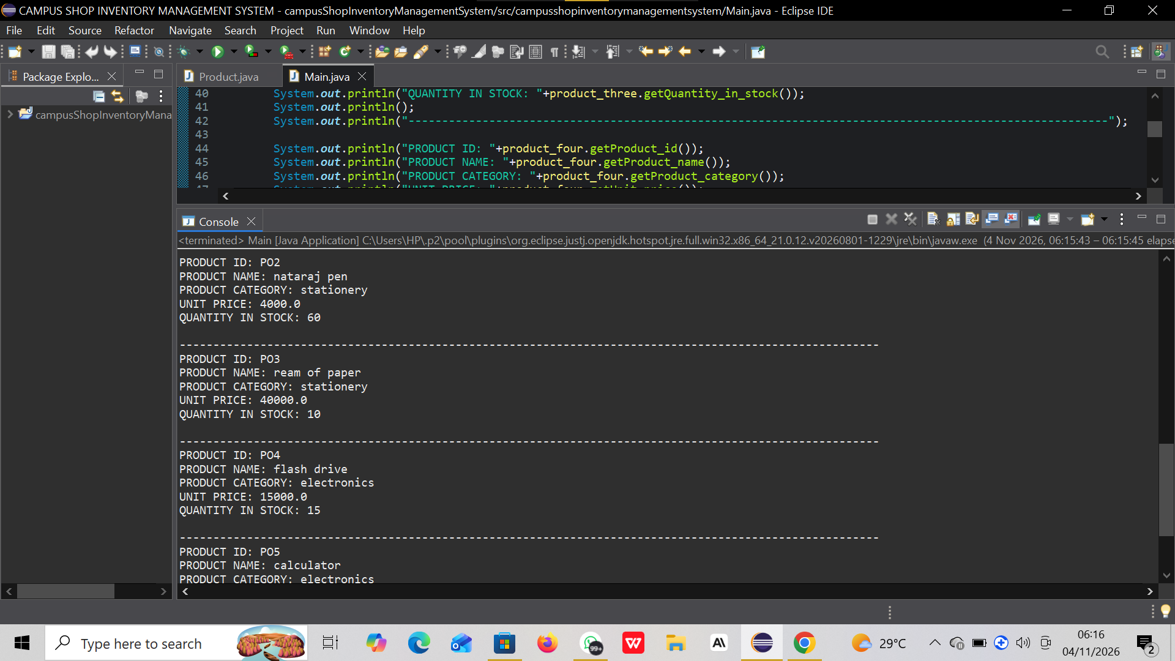
Another validation test for a negative value that is stock in quantity of product four.


